APPENDIX (Additional Tables and Figures)

App. Fig. 1. Proposed Path Analysis of Restaurant Employee’s Organizational-Based Self-Esteem, Intrinsic Job Motivation, Organizational Commitments, and Turnover Intention for Both the Fast Food Restaurant and Full Service Restaurant.
+
+
+
+
+
+
+
+
+
OBSE
Commitment
Affective
Intrinsic Job Motivation
Turnover Intention
Commitment
Normative
Commitment
Continuous
Note: OBSE means Organizational-Based Self-Esteem.

App. Fig. 2. Plot of Euclidean Distances from Cluster Center by Cluster Membership.
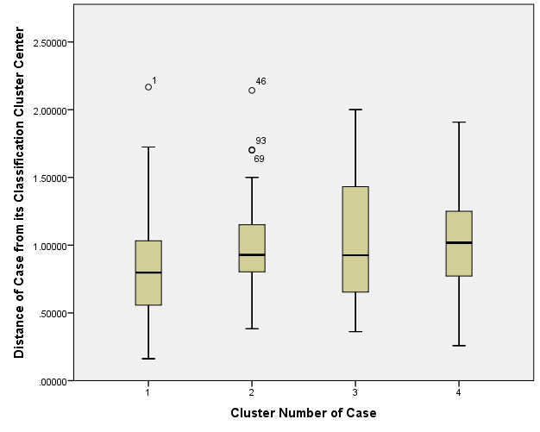
Note: The diagnostic plot helps find outliers within clusters. Compare to cluster three and four, cluster two have a few outliers, but all the distances are within reason.
Note: 1 = AC/NC dominant; 2 = AC dominant; 3 = CC dominant; 4 = NC dominant.

App. Table 1. Profile of Participants (N =160).
 | n | % |  | n | %
Gender |  |  | Education
Male | 79 | 49.4 | Some high school | 3 | 1.9
Female | 80 | 50.0 | High school graduate | 21 | 13.1
Age |  |  | Some college credits | 76 | 47.5
18 - 20 | 5 | 3.1 | Bachelor’s degree | 48 | 30.0
21 - 30 | 83 | 51.9 | Graduate degree | 11 | 6.9
31 - 40 | 37 | 23.1 | Position
41 - 50 | 14 | 8.8 | Full time | 114 | 71.3
51 - 60 | 15 | 9.4 | Part time | 43 | 26.9
> 60 | 5 | 3.1 | Restaurant Type
Marital Status |  |  | Fast food | 50 | 31.3
Single | 71 | 44.4 | Fast casual | 35 | 21.9
Married | 62 | 38.8 | Casual dining | 50 | 31.3
Widowed | 4 | 2.5 | Fine dining | 25 | 15.6
Divorced/ Separated | 22 | 13.8 | Years Working in Restaurant
 |  |  | 0-1 years | 18 | 11.3
 |  |  | 2-4 years | 58 | 36.3
 |  |  | 5-9 years | 50 | 31.3
 |  |  | > 10 years | 31 | 19.4
Note: Responses may not equal 100% due to non-response to a question.

App. Table. 2. Changes in Cluster Centers with Iteration History.
Iteration | Iteration History
 |  | Cluster 1 | Cluster 2 | Cluster 3 | Cluster 4
1 |  | 1.602 | 1.626 | 1.850 | 1.968
2 |  | 0.086 | 0.144 | 0.188 | 0.125
3 |  | 0.000 | 0.042 | 0.070 | 0.018
4 |  | 0.021 | 0.025 | 0.039 | 0.028
5 |  | 0.000 | 0.000 | 0.000 | 0.000
Note: The iteration history shows the progress of the clustering process at each step.
Note: Convergence achieved due to no or small change in cluster centers. The maximum absolute coordinate change for any center is .000. The current iteration is 5. The minimum distance between initial centers is 4.018.

